**Geography 475 Lab03 Write-Up**

**By: Arielle Wood**

1.1.1

Nitrate Points before Selection:

|  |  |  |  |
| --- | --- | --- | --- |
| X-Xavg | Y-Yavg | Mean Distance | Standard Distance |
| 6811.452 | -1835.81 | 80592.13 | 111538.6 |
| 7875.452 | -2795.81 |
| 3406.452 | -1475.81 |
| 3692.452 | -425.806 |
| 7883.452 | -5655.81 |
| 9272.452 | -6495.81 |
| 152.4516 | -2145.81 |
| 1009.452 | 3244.194 |
| -4713.55 | 1384.194 |
| -2427.55 | -2095.81 |
| -5078.55 | 3184.194 |
| -6919.55 | 5104.194 |
| -4760.55 | 10824.19 |
| -4427.55 | 8944.194 |
| -9761.55 | 12744.19 |
| -10420.5 | 8004.194 |
| -11214.5 | 5414.194 |
| -12531.5 | 5664.194 |
| -15079.5 | 5744.194 |
| -15008.5 | 9964.194 |
| -14381.5 | 3164.194 |
| -9579.55 | 3744.194 |
| -16103.5 | 12354.19 |
| -14016.5 | 13714.19 |
| 12985.45 | -6785.81 |
| -8710.55 | -3875.81 |
| -3524.55 | -6415.81 |
| -190.548 | -11075.8 |
| 6423.452 | -14615.8 |
| 5841.452 | -20065.8 |
| 16795.45 | -9965.81 |
| 13937.45 | -15305.8 |
| 19070.45 | -21655.8 |
| 20446.45 | -15675.8 |
| 10392.45 | -11285.8 |
| -18023.5 | 6394.194 |
| 11839.45 | -16245.8 |
| -4432.55 | 6964.194 |
| -13084.5 | -3225.81 |
| 13797.45 | -13095.8 |
| 1943.452 | -12405.8 |
| 15675.45 | -4385.81 |
| -12238.5 | 2644.194 |
| -728.548 | 21094.19 |
| 15834.45 | 5244.194 |
| 3822.452 | 6904.194 |
| 6124.452 | 15794.19 |
| 7023.452 | 20664.19 |
| -4062.55 | 15564.19 |
| 1626.452 | 7654.194 |
| 10198.45 | -13065.8 |
| -11444.5 | 10324.19 |
| 4721.452 | 10774.19 |
| -3030.55 | 4344.194 |
| -7554.55 | 1114.194 |
| -13269.5 | -605.806 |
| 6097.452 | 3974.194 |
| 1784.452 | 1694.194 |
| 7499.452 | -8675.81 |
| 2552.452 | -6905.81 |
| -13296.5 | -7195.81 |
| 13479.45 | -8885.81 |

Nitrate points after Selection:

|  |  |  |  |
| --- | --- | --- | --- |
| X-Xavg | Y-Yavg | Mean Distance | Standard Distance |
| 12059.64 | -2519.09 | 44112.44 | 59722.82 |
| 13123.64 | -3479.09 |
| 8940.636 | -1109.09 |
| 13131.64 | -6339.09 |
| 14520.64 | -7179.09 |
| 534.6364 | 700.9091 |
| -4513.36 | 12060.91 |
| -5172.36 | 7320.909 |
| -5966.36 | 4730.909 |
| -7283.36 | 4980.909 |
| -9831.36 | 5060.909 |
| -9760.36 | 9280.909 |
| -9133.36 | 2480.909 |
| -4331.36 | 3060.909 |
| -10855.4 | 11670.91 |
| -8768.36 | 13030.91 |
| -3462.36 | -4559.09 |
| 1723.636 | -7099.09 |
| 5057.636 | -11759.1 |
| 11671.64 | -15299.1 |
| -12775.4 | 5710.909 |
| 11089.64 | -20749.1 |

1.1.2

**1. Describe the total well-location pattern across Brazos County using the metrics that you generated.**

The mean distance is 80592.13. Mean distance is the mean of the maximum and the minimum distances between the points. It essentially shows the mean space between the points. In this case, it describes the mean distance between the well locations. The mean distance is relatively high suggesting that the well locations patterns are located far from each other.

The standard distance is 111538.6. Standard distance shows the distribution of the features around their relative center. In this case, the standard distance is showing how far each well location is from the relative center of all the well locations. Since this number is relatively high, it shows that the wells are distributed without a focus on distances from a relative center. They were likely randomly distributed.

**2. Describe the well-location pattern for contaminated wells across Brazos County. Compare and contrast the distributions.**

The mean distance for the contaminated wells is 44112.44. This is a significantly smaller mean distance than the total wells. This means that the contaminated wells are distributed close to each other. The standard distance for the contaminated wells is 59722.82. This is significantly lower than the standard distance for all the wells. This shows that the contaminated wells are distributed around a relative center.

1.2.1

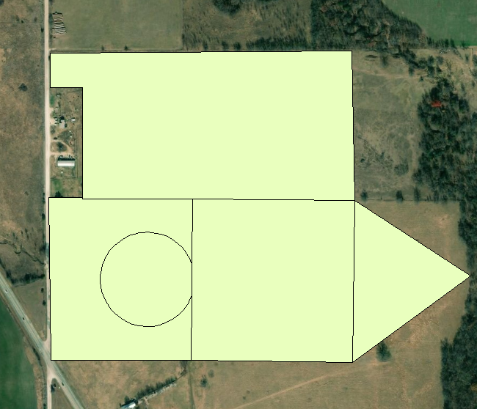

|  |  |  |  |  |  |  |  |
| --- | --- | --- | --- | --- | --- | --- | --- |
|  | Area | Perimeter | Max length | Shape Index | Shape Compactness Index | Shape Elongation Index | Shape Fractal Dimension |
| Circle | 24044.75 | 549.6866 | 174.9647 | 0.022861 | 0.99997 | 1.000049 | 1.250903 |
| Square | 90033.34 | 1200.222 | 424.3426 | 0.013331 | 0.785375 | 0.797896 | 1.24304 |
| Triangle | 32511.87 | 827.606 | 300.0563 | 0.025456 | 0.596474 | 0.678078 | 1.29335 |
| Elongated Polygon | 141343.8 | 1672.381 | 627.5157 | 0.011832 | 0.635043 | 0.676044 | 1.251713 |
| Complex Polygon | 55345.05 | 1565.262 | 398.7247 | 0.028282 | 0.283858 | 0.665775 | 1.347052 |

1.2.2

**1. Is the shape index sensitive to variations in the size of a polygon, given each shape?**

It is very slightly impacted by the size of the polygon. The largest changes to be noted is the changes between values close to 0.02 to values close to 0.01. The trend noticed in comparing the numbers with the size of the shapes is that the shapes with smaller areas produce a higher shape index close to 0.02. This trend indicates that the shape index is influenced by variations in the size of the polygons. It is not a large change, but it is present.

**2. Is the shape compactness index sensitive to variations in the size of the polygon, given each shape? Based upon your analysis, how would you define the term compactness, and what does it really represent?**

The changes in the numbers for the shape compactness index does not reflect any correlation to the relative sizes of the polygons they represent. This means that the term compactness does not relate to the size of the polygons. Compactness refers to the complexity of the shapes. The circle, having the least complex sides, produces an answer closes to 1. The complex polygon had the lowest number since it has the most complex sides. The numbers reflect the complexity of the polygon.

**3. Is the shape-elongation index sensitive to variations in the size of a polygon, given variations in the maximum and minimum lengths?**

The shape elongation index is not directly related to the size of the shape. This is shown through the lack of correlation between the area calculations and the shape elongation index calculations. The best example of this non-correlation is the triangle area compared to the elongated polygon area. The elongated polygon has a significantly larger area, yet they have very similar shape elongation indexes. The triangle has an elongation index of 0.678078, whereas the elongated polygon has an elongation index of 0.676044. This difference does not reflect the same magnitude of difference between the areas, thus the elongation index does not reflect the size of the shapes.

**4. Is the shape fractal-dimension index sensitive to variations in the size of a polygon, given each shape? What does the index really characterize? Demonstrate this by generating additional polygons that characterize the concept. Compare and contrast.**

The shape fractal-dimension index is not sensitive to the variations in the sizes of the polygons. This is shown through comparing the magnitude and trends of the areas to the magnitude and trends of the calculated fractal-dimension index. When the area calculations change, the fractal-dimension calculations change in a different trend. The shape fractal dimension index characterizes the complexity of the shape as shown through the number of sides and the manifestations of the sides.

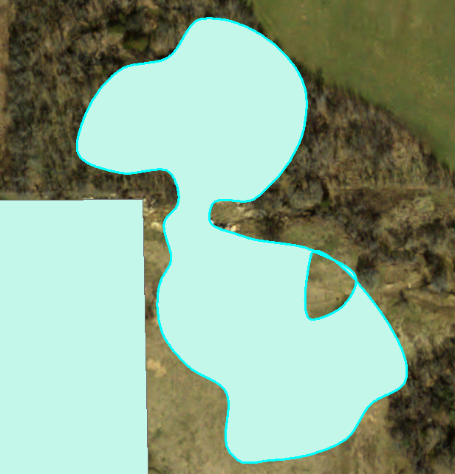

The image above is a newly created polygon to show that the fractal dimension index shows the complexity of the shape. This shape is very complex in that it has many sides and most of them have a circular dimension. The calculated fractal-dimension index for this shape is 1.373393. This is the highest index of all the shapes because it is the most complex. The second highest is the complex polygon because it has multiple sides and one of them is a semi-circle. The higher the number, the more convoluted and complex the shape. Shapes with simple perimeters, like squares, have indexes closer to 1, whereas complex shapes, like circles and complex polygons, have numbers closer to 2.

**5. Based upon your analysis, do you think that any one of these metrics can be used to diagnostically differentiate between geometric and complex shapes?**

Yes, the fractal-dimension index could be used to differentiate between geometric and complex shapes. There would be complications with shapes very similar to a circle. This is because of the duality of the classification of the circle shape. It is a geometric shape, yet, the numeric classification calculated in the fractal-dimension index declares it as a complex shape. This index could be used to differentiate, but it would be more accurate if accompanied by visual analysis to double check the complexity results.

1.3.1

Landsat8 Global Least Complex Area Semivariogram:

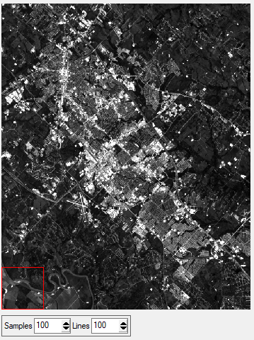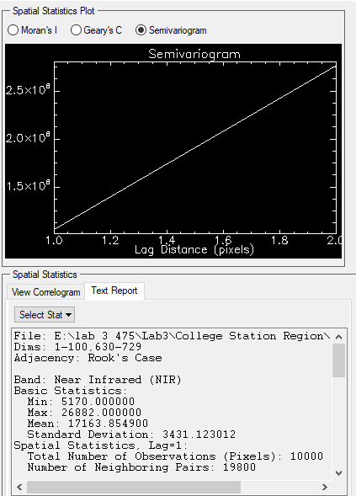

Landsat8 Global Middle Least Complex Area Semivariogram:

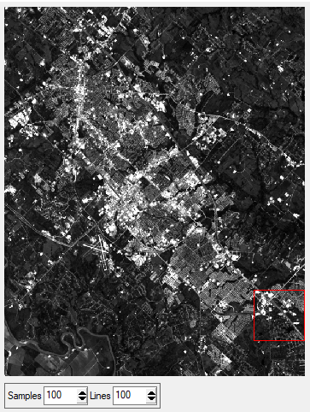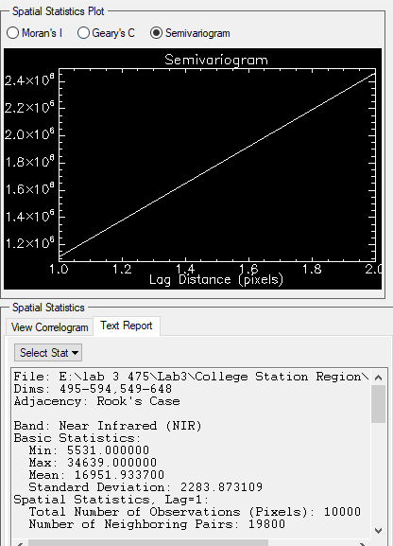

Landsat8 Global Middle Highest Complex Area Semivariogram:

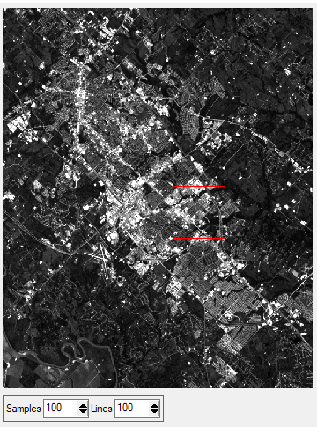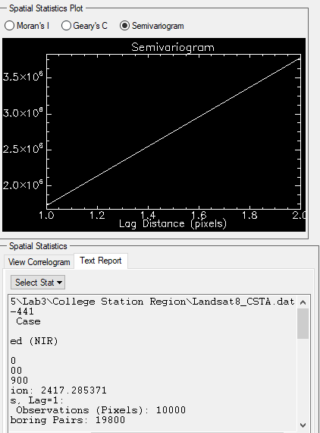

Landsat8 Global Highest Complex Area Semivariogram:

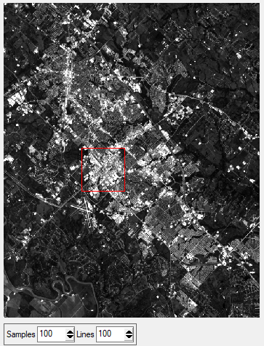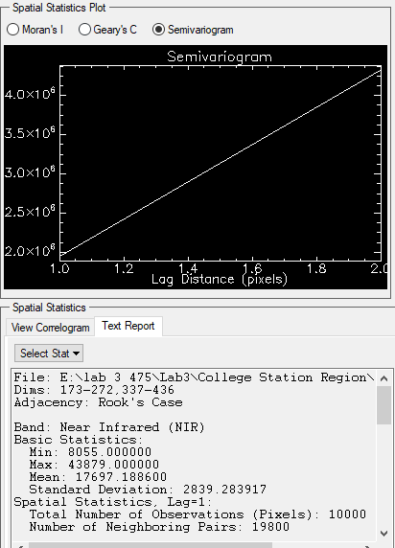

Landsat8 Local Least Complex Area Morans Index:

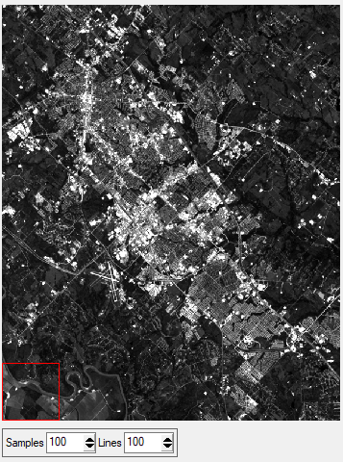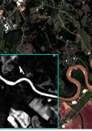

Landsat8 Local Middle Least Complex Area Morans Index:

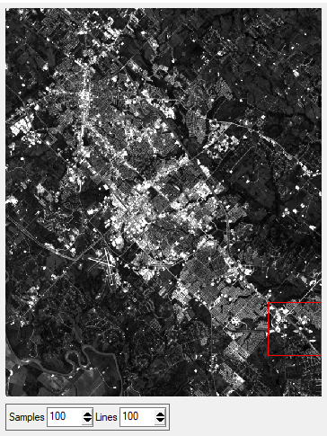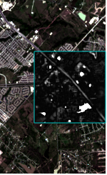

Landsat8 Local Middle Highest Complex Area Morans Index:

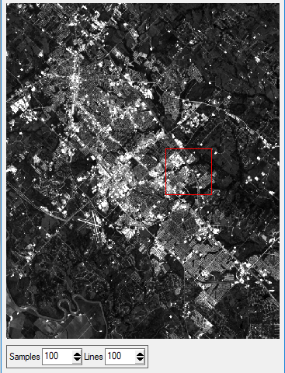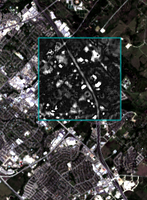

Landsat8 Highest Complex Area Morans Index:

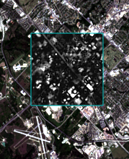

DEM Global Least Complex Area Semivariogram:

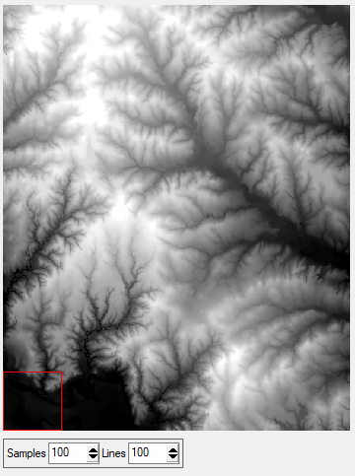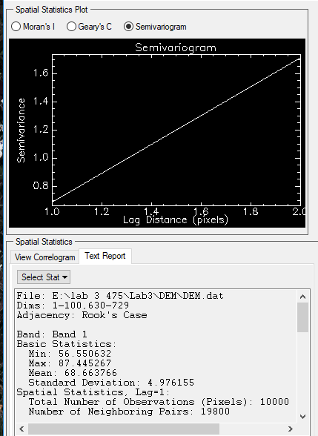

DEM Global Middle Least Complex Area Semivariogram:

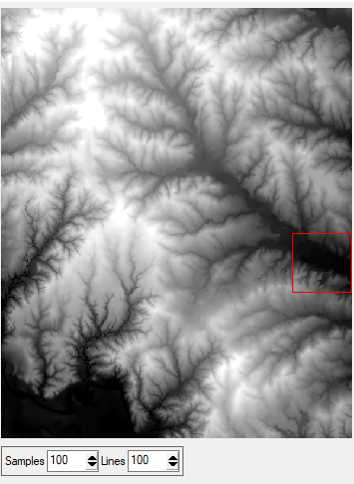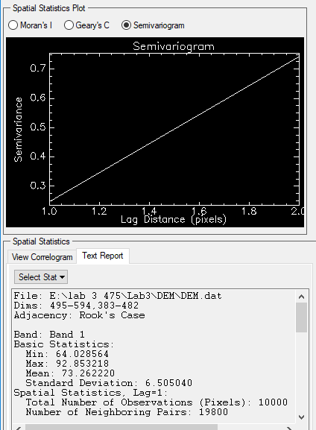

DEM Global Middle Highest Complex Area Semivariogram:

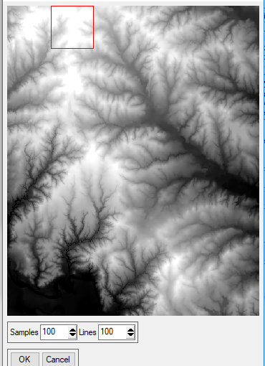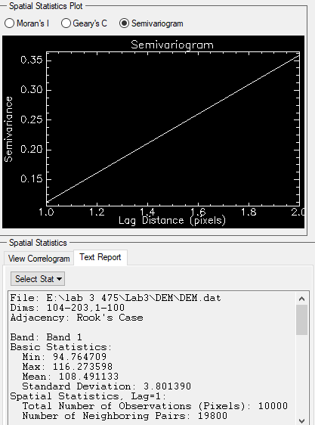

DEM Global Highest Complex Area Semivariogram:

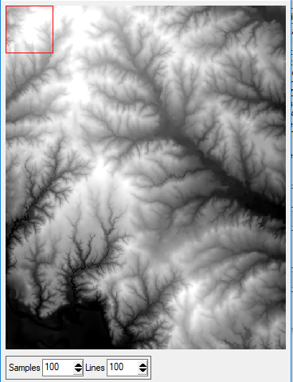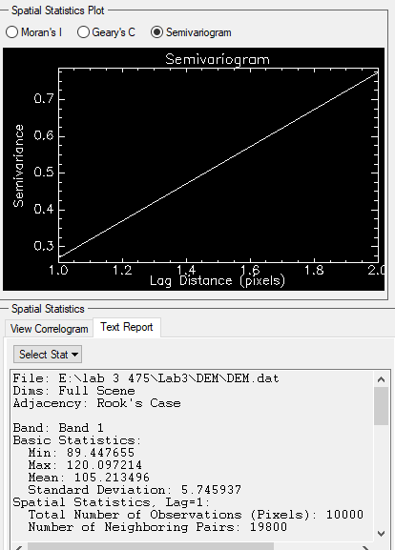

DEM Local Least Complex Area Morans Index:

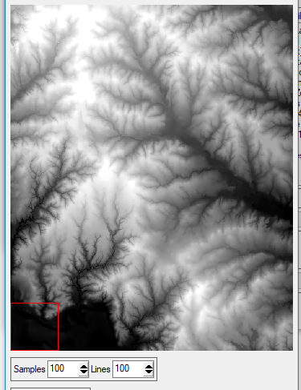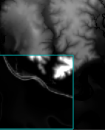

DEM Local Middle Least Complex Area Morans Index:

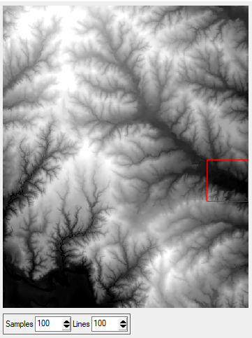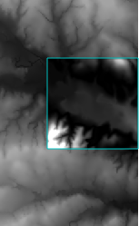

DEM Local Middle Highest Complex Area Morans Index:

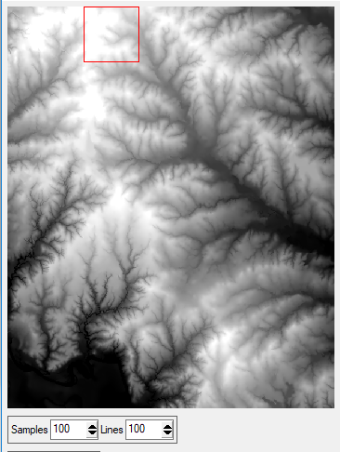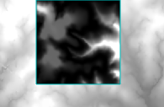

DEM Local Highest Complex Area Morans Index:

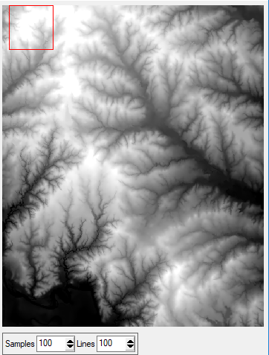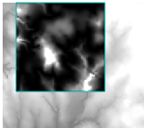

**1. Did your first two samples accurately depict relatively high versus relatively low spatial variation in spectral and relief variations? How do you know this? Provide evidence based upon your interpretation of the semivariograms? Was there any significant scale-dependent variation that is related to structural or environmental conditions, or was the variation relatively constant with scale (lag distance)? What was the scale at which spatial autocorrelation exists for your initial four samples?**

Upon looking at the semivariograms produced by the samples, a distinct difference between high and low areas of complexity cannot be immediately noted. This is observed by looking at the linear model produced. The models look identical. The only difference to be noted is the differences in the basic statistics generated at the bottom of each semivariogram.

The variation was relatively constant with the scale, otherwise known as the lag distance. The lag distance used for the samples was 2. The sample scale was the same for all the samples taken. It was 100x100.

**2. Could you find geographic areas with greater or less spatial variability? How did these compare to your initial sample sets?**

Yes. For the spectral samples, areas that appeared more urban and denser were deemed the highest in complexity. The areas that appeared less urban and less dense were deemed the lowest in complexity. These matched with the initial samples taken since they all followed the same pattern. For the relief samples, the regions that appeared to have the most intense lightness were deemed the highest in complexity. The regions that appeared to have the most intense darkness were deemed the lowest in complexity.

**3. Where you able to obtain a systematic increase in the degree of spatial complexity for your 4 samples (reflectance and relief). Did your Moran’s I statistic for each sample validate this? If you did not have a systematic progression, resample the data to obtain such a progression. Finally, what environmental condition cause the higher degree of spatial complexity?**

I was able to obtain a systematic progression. This was due to the pattern in which the samples were chosen and the way in which the regions were selected. The greyscales produced through the Moran’s Index indicated the regions of higher and lower complexity. This was done through the clarity of the greyscales produced. The regions with high spatial complexity were the regions with the most change in the topography. This was shown through the greyscales produced from the perceived regions of lowest complexity.

2.1

Point density map with Circle neighborhood:

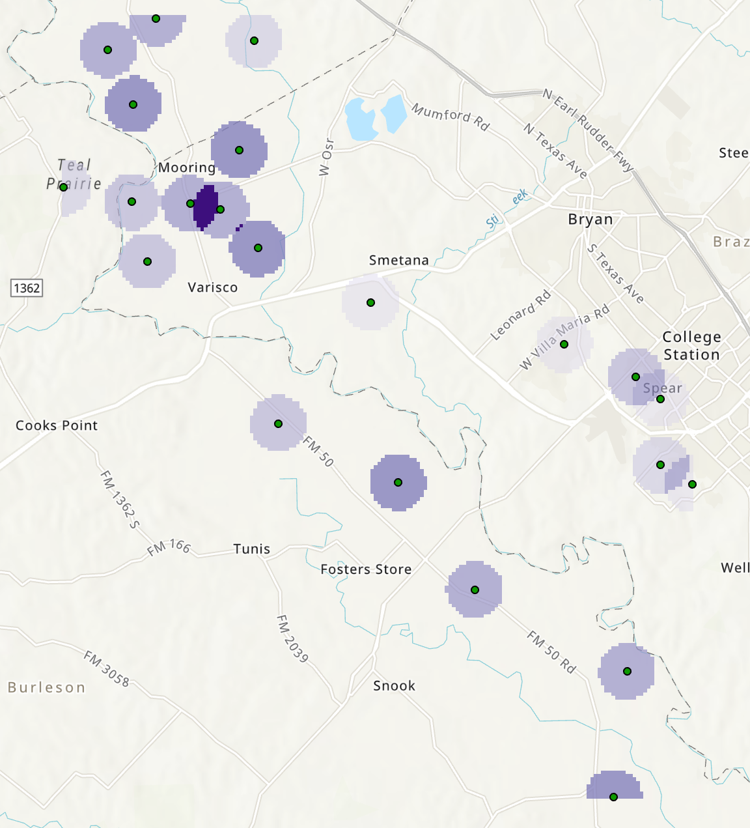

Point density map with Rectangle neighborhood:

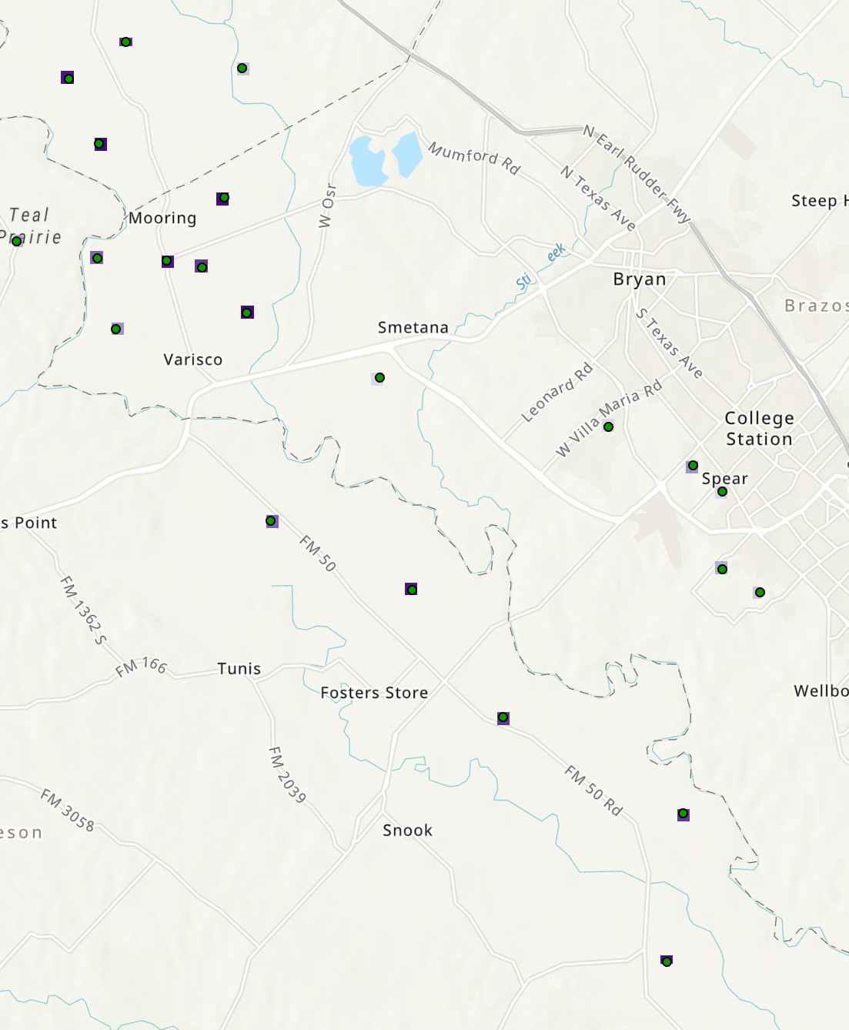

Point density map with Wedge neighborhood:

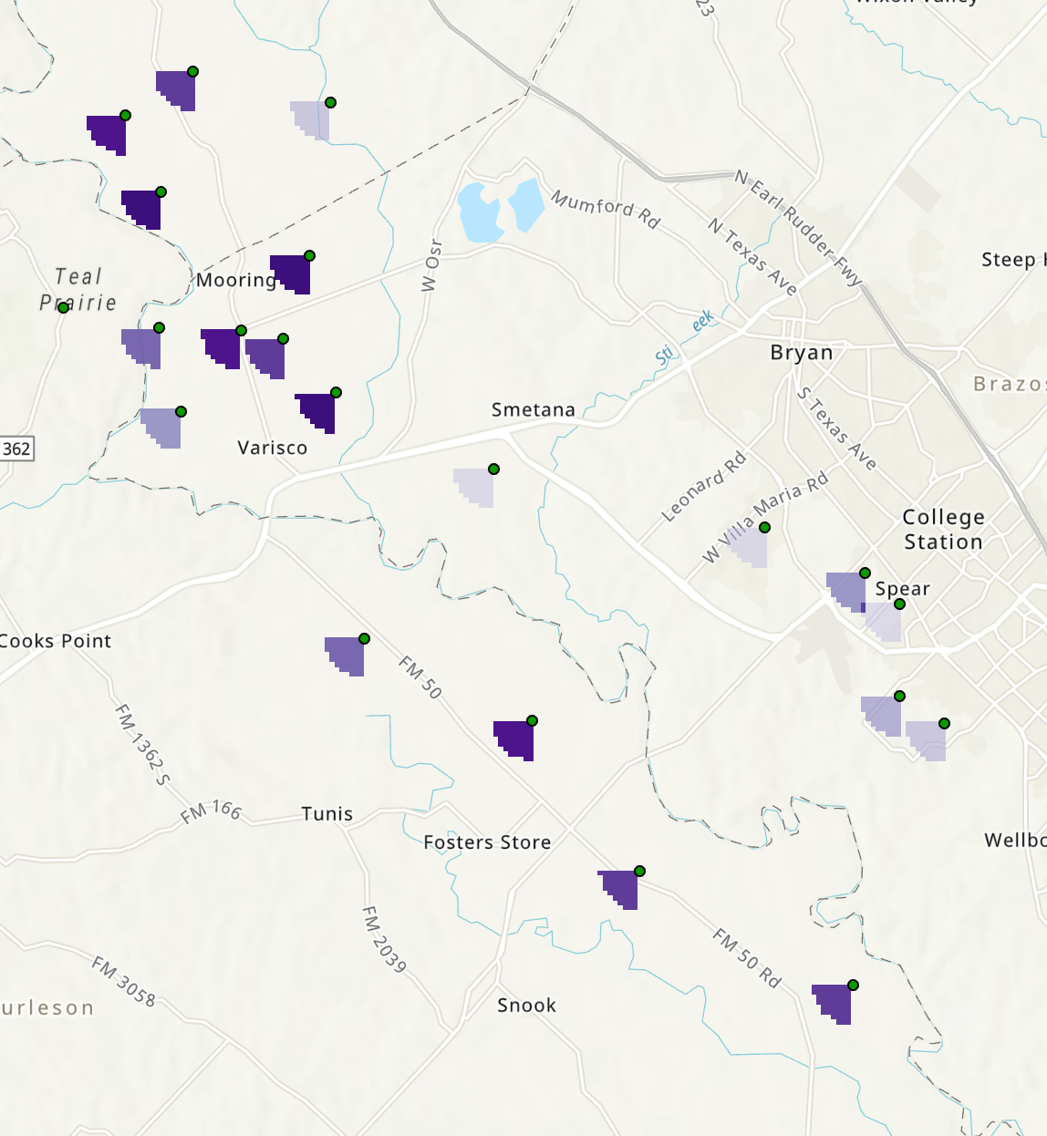

Kernel density map with Planar method:

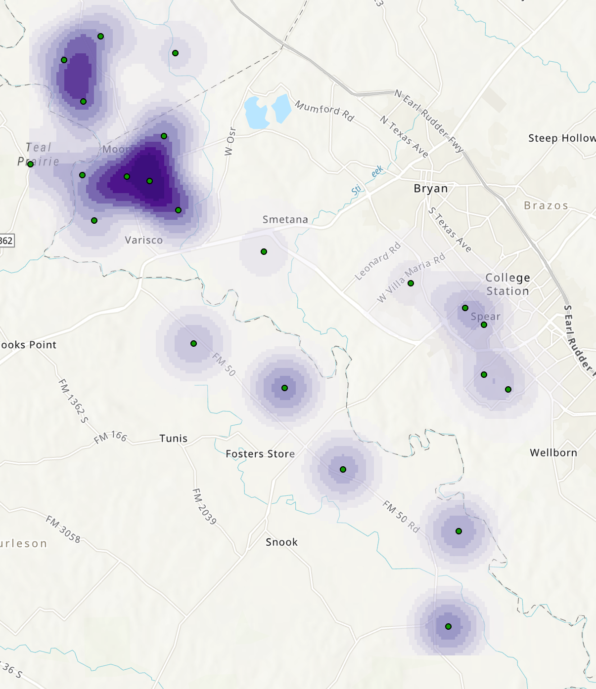

Kernel density map with Geodesic method:

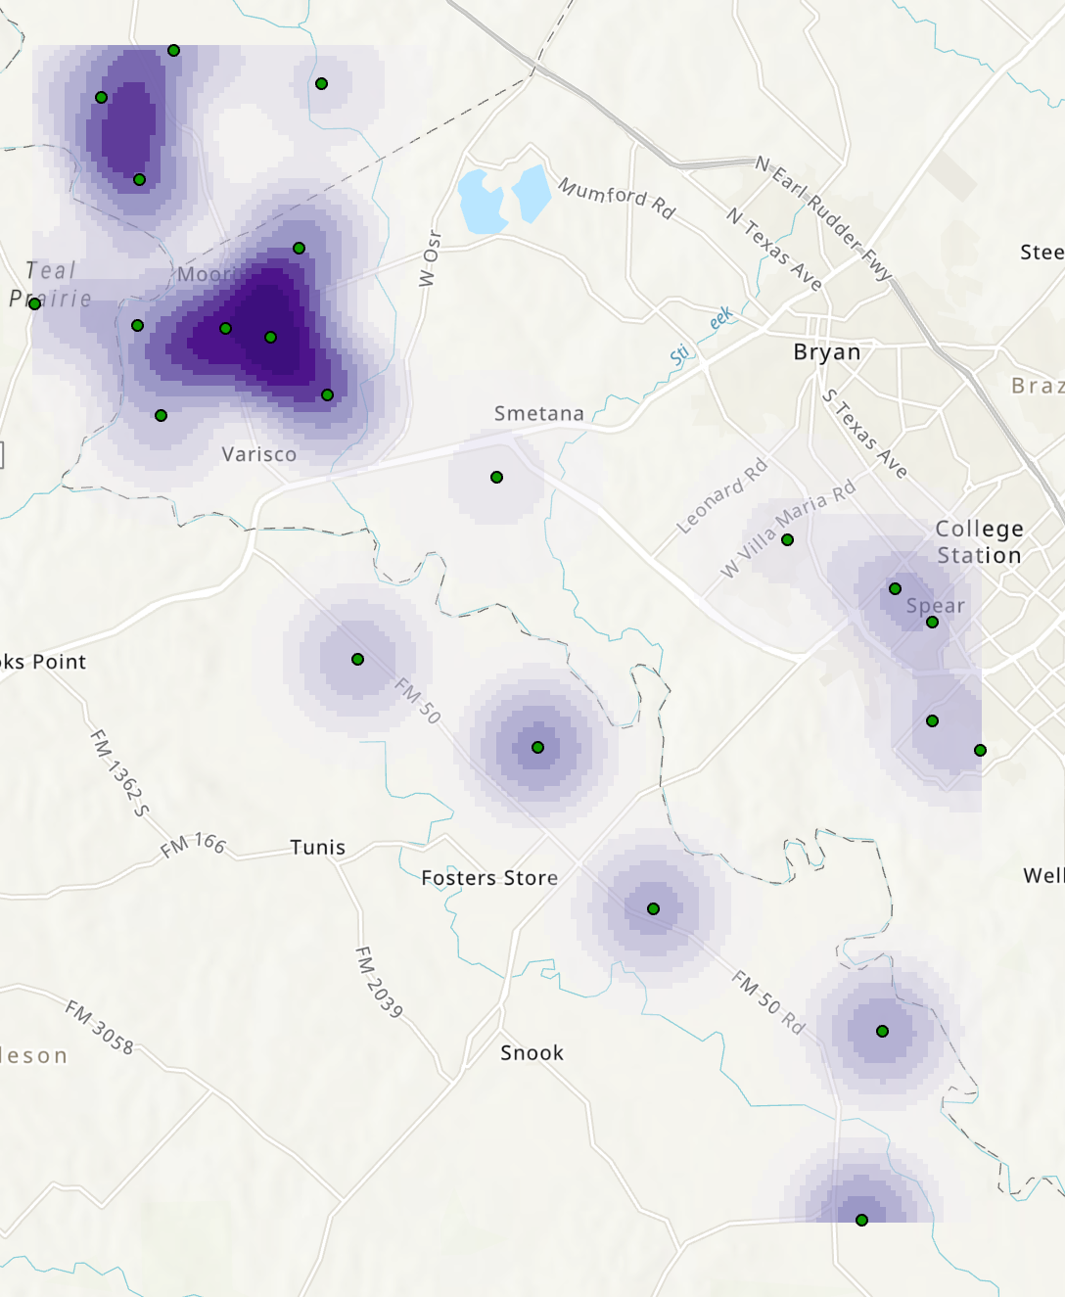

2.2

**1. Compare and contrast the point patterns derived from the point density tool and from different neighborhood shapes. Does the shape of the neighborhood influence the spatial distribution of contamination?**

The point density map is directly influenced by the neighborhood types. The circular neighborhood type displayed the most information. It used color depth to show the intensity of the contamination and included overlapping areas. It was the most effective point density neighborhood shape. The rectangle neighborhood shape displayed the least amount of information in the least effective way. This neighborhood type not only affected the shape of the data displaying mechanism, it also changed the size. The size became so small, the information was almost unnoticeable. It made for a difficult analysis. The wedge neighborhood type displayed the information in a wedge shape facing south to southwest. This displayed the information but left room for interpretation as to the orientation of the wedge and its potential significance. This affected the effectiveness of the display since the orientation is not a significant aspect.

**2. Compare and contrast the point patterns derived from the kernel density tool and from different kernels and varying search radius. Does the mathematical characteristics of a kernel influence the spatial pattern that is obtained (be sure to keep the radius constant when you compare results)? Does the extent of the kernel influence the point-pattern distribution? How would you determine which kernel and distance to use to accurately depict potential hotspots of groundwater contamination?**

The difference between the kernel densities is the method used. The two methods used were planar and geodesic. The planar had a smaller region shown as contaminated. The geodesic had a larger region shown as contaminated. The extent influences the point pattern in that it affects the area of region described as contaminated. I would use the geodesic method because it shows a wider extent. In circumstances of contamination, it is better to overestimate than to underestimate.

**3. Compare and contrast the results from the point density and the kernel density tools? Do they present similar or different point-pattern results?**

The kernel density has a much better representation of the data. The point density underrepresents the data, and in the case of the wedge neighborhood, the representation can be viewed as confusing as it alludes to the direction of the wedge being significant. The wedge location is not a significant factor within the dataset. They have different results. The point density is not as good of a representation of the data as the kernel density. The kernel density shows the relationship between the wells in the best manner.

**4. Finally, interpret your point-pattern analysis results. What do the results suggest about the sources of ground water contamination in Brazos County? Can these patterns be attributed to natural processes or anthropogenic factors? Be specific in terms of what you hypothesize is the cause of the ground water contamination. Be sure to utilize additional spatial data to help verify your interpretation.**

In the northwest section of the map, near the lakes, the water contamination is the most dramatic. This likely indicates that the contamination originates around the mooring region. This is shown by looking at it through the topology and the density of the kernel density map. These patterns are likely most strongly influenced by natural processes, but also highly influenced by anthropogenic processes. I hypothesize that the contamination was caused by the amount of oil wells in the region.